**CHANDIGARH UNIVERSITY**

**UNIVERSITY INSTITUTE OF ENGINEERING**

**DEPARTMENT OF COMPUTER SCIENCE AND ENGINEERING**



|  |  |
| --- | --- |
| **Submitted by: Yash Gupta 20BCS5009** | **Submitted To:** |
| **Subject Name:** | Java |
| **Subject Code:** | 20CSP-317 |
| **Branch:** | CSE |
| **Semester:** | 5th |

LAB INDEX

|  |  |  |  |  |  |  |  |
| --- | --- | --- | --- | --- | --- | --- | --- |
| Sr.  No | Program | Date |  | Evaluation | | | Sign |
| LW  (12) | VV  (8) | FW  (10) | Total (30) |
| 1. |  |  |  |  |  |  |  |
| 2. |  |  |  |  |  |  |  |
| 3. |  |  |  |  |  |  |  |
| 4. |  |  |  |  |  |  |  |
| 5. |  |  |  |  |  |  |  |

# 

**Lab MST**

**Aim/Overview of the practical:**

**Code:**

import java.util.*;  
abstract class Shape{  
 abstract void area(int l, int b);  
}  
class Rectangle extends Shape{  
 void area(int l, int b){  
 System.*out*.println("Rectangle :" + ( l * b ));  
 }  
}  
class Circle extends Shape{  
 void area(int l, int b) {  
 int r = l;  
 System.*out*.println("Circle :" + ( 3.14 * r * r ));}  
}  
class Triangle extends Shape{  
 void area(int l,int b){  
 double a=(0.5 * l * b);  
 System.*out*.println("Tiangle :" + a);  
 }  
}  
  
public class Main {  
 public static void main(String args[])  
 {  
 Shape obj = new Rectangle();  
 obj.area(3,4);  
  
 Shape obj1 = new Circle();  
 obj1.area(5,0);  
  
 Shape obj2 = new Triangle();  
 obj2.area(24,20);  
 }  
}

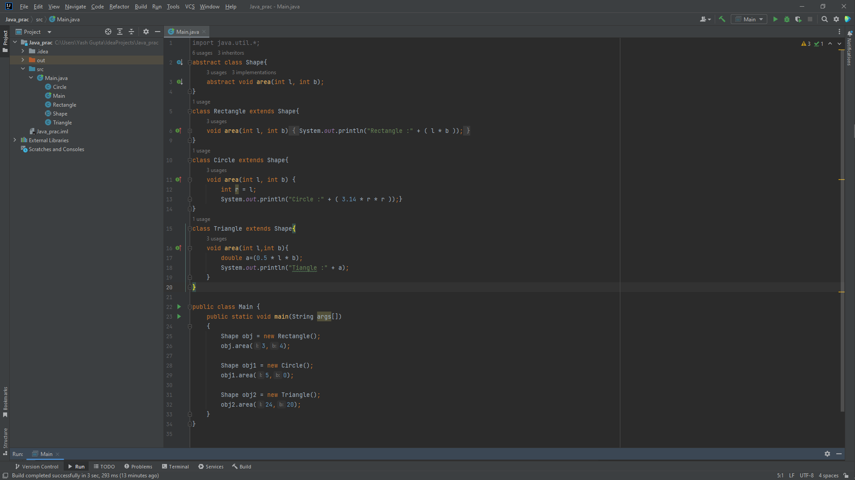

**Output:**

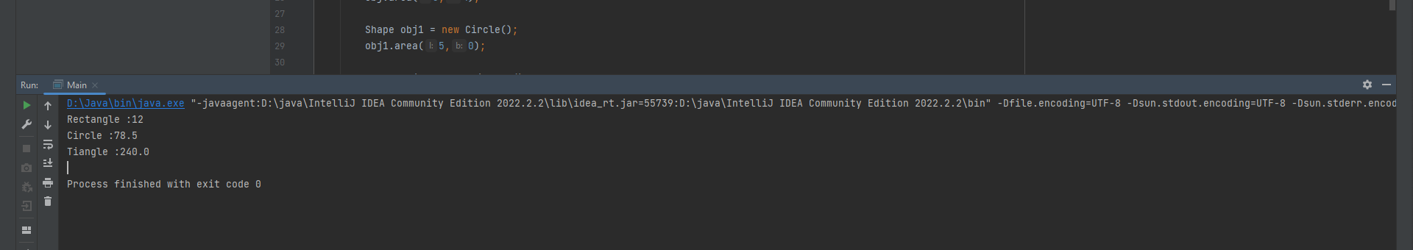

**Evaluation Grid (To be created as per the SOP and Assessment guidelines by the faculty):**

|  |  |  |  |
| --- | --- | --- | --- |
| Sr. No. | Parameters | Marks Obtained | Maximum Marks |
| 1. |  |  |  |
| 2. |  |  |  |
| 3. |  |  |  |
|  |  |  |  |